13 – ReactJS-HOL
Data Definition Model Snippet
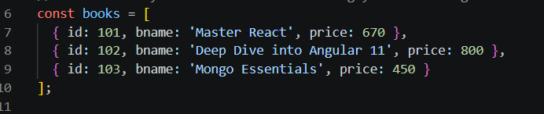
Rendering Lists with Unique Extract Keys
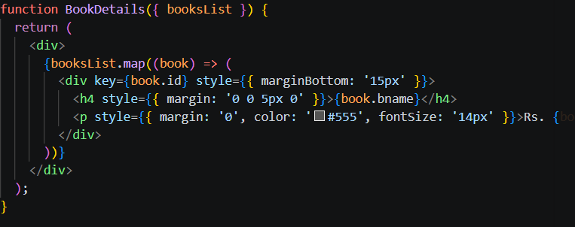
Layout Definition Structure
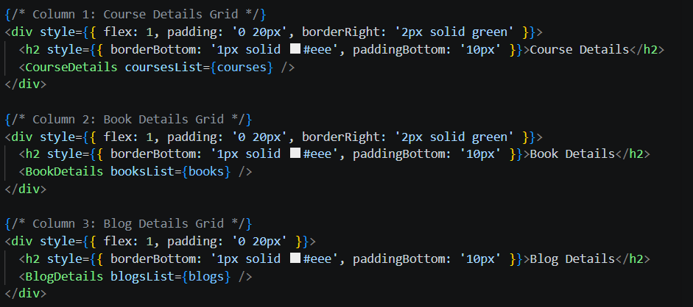

Code Output:
